

V1 – July 2019

Contact Us
Paediatric enuresis team.
Rotherham hospital,
Telephone- 01709 427596
E.mail-rgh-tr.paediatricenuresisteam@nhs.net

A referral to ourselves may be appropriate from the G.P/Health professional if any of the concerns mentioned in this booklet are identified.



Keeping Your Child’s Bladder Healthy
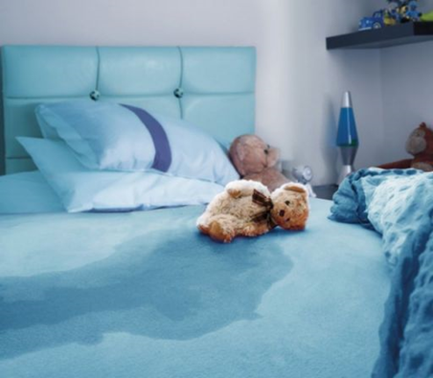

An information guide for parents and schools

Table of Contents
How we can help 1

Our Mission Statement…………………………………………………………………………….2

Enuresis……………………………………………………………………………………………………3

Paediatric Enuresis service ……………………………………………………………………..4

Top tips …………………………………………………………………………………………………..5
- Constipation
- Bad Habits
- Fluids and fluid intake

Who we are and contact details. 6

Top Tips- for Parents and Schools

Constipation:
 | Sometimes constipation can cause a child to suffer from enuresis – assess for any symptoms such as abdominal pain, pain passing stool, withholding and opening bowels less than 4 times per week.  A visit to the G.P. is required if suspected.
  

Bad Habits:
 | Is your child emptying their bladder properly? are they sitting on the toilet relaxed and in the correct position? are they accessing a toilet regularly throughout the day? (4-7 wee’s a day is recommended). At bedtime ensure your child goes for a second wee just as you turn out the light to ensure the bladder is fully empty.
  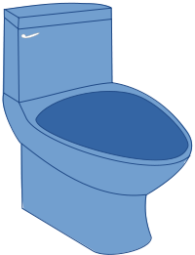

Fluids and fluid intake
 | Ensure your child is able to access drinks regularly throughout the day- appropriate volume for age. Information of this can be found on the ERIC website (http://www.eric.org.uk). At school they will need to drink at least a half of their daily required volume to promote dry nights. Children need to drink water based fluids, avoiding caffeine, carbonated (fizzy), and blackcurrant flavoured drinks. (6-8 drinks per day).
  
5

Paediatric Enuresis Service

Bedwetting
 | Bedwetting is completely involuntary. It is not usually caused by poor parenting, toilet training mistakes, stress or mental health.
  

Daytime wetting
 | Children who struggle to keep dry in the day should always be checked out by their G.P. to rule out any underlying cause.
  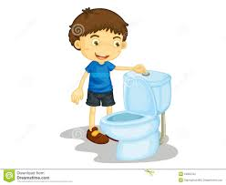

Toileting issues
 | Some children are delayed in being successfully toilet trained for a variety of reasons. These may be behavioural/emotional/physical in origin.
  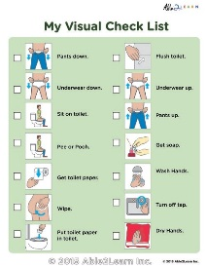
A referral to ourselves may be appropriate from the G.P/Health professional if any of the above concerns are identified.

Who we are:

Hello, we are a specialist enuresis team who are here to help local children aged 5 -16 years who are registered with a Rotherham G.P.

We aim to help children and families who have any toileting issues/concerns such as bedwetting, toilet avoidance, delayed toileting, daytime wetting issues that have not yet resolved.

How we can help
“Our service was set up to help to improve the quality of lives of children and their families, by using all the latest information and guidance on enuresis to ensure we deliver a unique, child and family-centred approach.”

Our knowledge and skills

- Bedwetting – causes and suggested treatments

- Daytime wetting issues – frequency, urgency, fluid intake advice, voiding behaviours, bladder retraining

- Toileting issues – behavioural /emotional/physical concerns, toilet avoidance, delayed toilet training.

Our Mission Statement

“To improve the health and wellbeing of the population we serve, building a healthier future together.”

Ambitious –striving to make change.

Caring-supporting children and their family/carers.

Together – ensuring the child/family receives the most appropriate care they need.

Enuresis-Bedwetting

Enuresis is not usually caused by poor parenting, toilet training mistakes, stress or mental health….
- The prevalence of enuresis decreases by about 15% each year of the child’s life.

- There is a strong hereditary link. There is a 40% chance of occurrence if one parent had enuresis and 70% chance if both parents were affected.

Some children have smaller bladders, and some produce more urine through the night, or do not wake to triggers of a full bladder, they may not produce enough antidiuretic hormone, which regulates urine production.

