Y6 Painting
About this unit: This unit builds on colour development ,skills in different paint media, composition and creativity.
Vocab | Suggested artists
Distortion  Anamorphosis  Human form – pose  Gesture  Contortion  Transform  Abstract  Vary  Portray  Representation depict  Portray  Resources  “Magic in art” book – By Alexander Sturgis  Collect lots of shiny objects  Spoons, bottles etc  Convex or concave mirrors (see Mrs T)  Fluorescent paint, water colour, powder ,acrylic  paint.  Author biographies  Photocopies of pics for visual aids and small versions for sketch books.  Create a sheet to reflect and evaluate the project and finished piece. | Francis Bacon  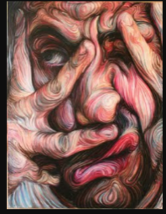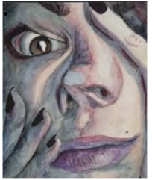  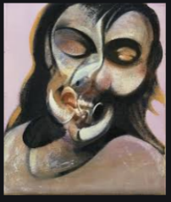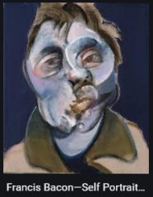 | Andy Warhol  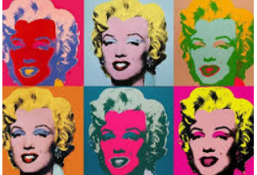  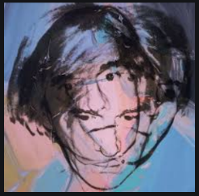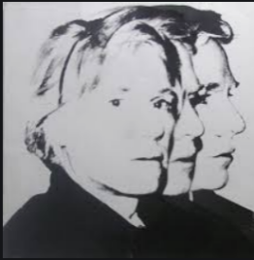  Self portrait | Pablo Picasso  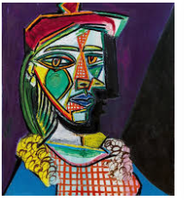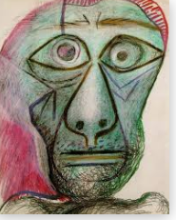  Self portrait  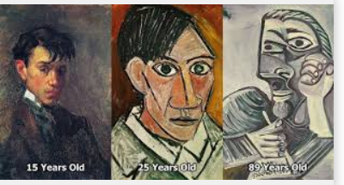
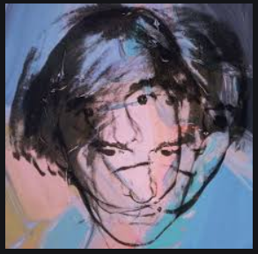
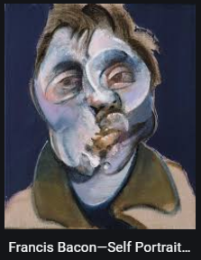
Explore and develop ideas.
Lesson 1 – first impressions
- Stick the 3 pictures right in the middle of a sketchbook page. Ask the
Children what they notice and label each around the pictures. Think about
subject, media, colour,time, art movement, artists, similarities, differences, personal
response, what stands out? etc
- Discuss ideas they’ve come up with and if the children want to add any more
annotations during the discussion, that’s fine.
- Are any of the children familiar with the artist? Introduce them and give the children some background info about them.Show other pics by them too. Introduce the word anamorphosis – which means distortion.
- Read about it in “Magic in art” book. Pg18 – 20..You could photocopy the relevant pages so the kids try out the tricks for themselves.
- You may want to set some homework for them to research the artist(s) and create a fact sheet with pics and info about them. This work can then be added to the sketchbook.
Lesson 2
- Talk about the ways you could distort an image.( see pics in Y5 online folder) photocopy large versions so they can refer to them easily.

- 1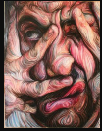 2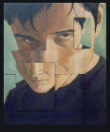 3 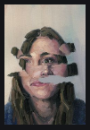 4 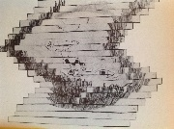5 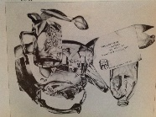

- 1.Physically – By pushing your face into unusual shapes with your hands.2. Cutting into and rearranging 3. Ripping 4. Cutting into strips 5.Reflections in different shaped objects.
- Let the children explore the different ways they can distort their image using shiny objects and mirrors.
- Take at least 3 photos with ipads of different distortions of themselves and reflections and print the three pictures ready for the next lesson.
- Give the children a copy of the 5 distortion suggestions above.Let the children stick these into their sketch books and annotate them to say how they have been distorted, while the other children are taking photos.
Investigating and making
Lesson3 – Sketchbook paint play
- Discuss the choices of paint media they wish to use. Water colour, paint – watercolour, powder, acrylic or ready mixed fluorescent.
- Look at examples of work using the different media and etc. Try out a mood page(s) in the sketchbook exploring different paint techniques, mixing it thin like a wash or thick and lumpy with acrylic, or adding bits of paper or strips of tissue paper into the paint etc (See Y5 online folder)
- Can they combine the paint with textures too eg paper, sand , or make the paint thick ,watery, or give it a shiny finish by brushing pva over etc ?
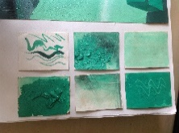
- Do they know which colours clash, complement each other or are opposite colours on the colour wheel? Find out and add these to the page writing notes to identify each one.
- Try putting some different clashing, complementary and opposite colours next to each other. Annotate their thoughts on the page and make notes. NB make the page creative. (See the pages on using sketchbooks in the policy.)
Evaluating and developing work
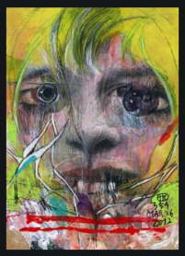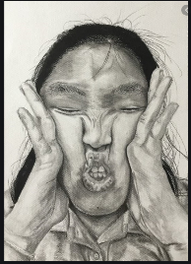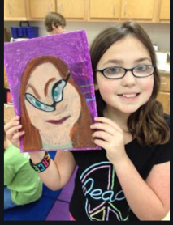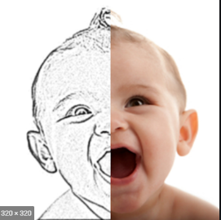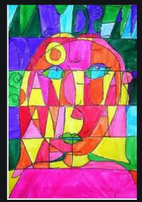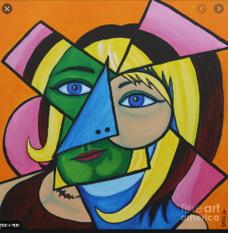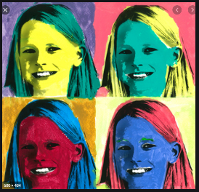

Lesson 4 – Gathering ideas
- As a class look at a variety of ideas about painting a distorted portrait. The pictures above were done by children. Discuss media, composition, artists that inspired the picture etc..
- Encourage the children to have a first attempt at drawing some distortions of their own face.
- You model how to draw a quick small picture(thumbnail), try at least 4 different different ways of distorting their face, they may need to use the photos to cut or tear, or to stick in photos of themselves distorting their own face in a mirror. Then write what they like or dislike about them underneath.
- Discuss, share and show their ideas to the class, others may say which ideas they like or give suggestions or ask questions.

Lesson 5 –Planning and beginning the final piece
- Look back in the sketchbook and pick the idea you like the best and which you will use to produce your final piece.
- Do a thumbnail sketch of it in pencil and maybe pencil crayon just to get a rough idea of what it may look like, label the elements in it like a diagram. Choose the size of paper you want to use.
- Then go for it!

Lesson 6 – Finish and evaluation
- Prepare an evaluation sheet for the children to use to reflect on their learning.
- Discuss together, do they like their work? Does it have the essence of the artists studied? How? Which bit is most successful? Why? If they did another piece would they change anything they’d done before? Why? Share these outcomes with the class and stick the sheet in the sketchbook to use for future reference
Prior learning
The children will have had experience with a range of paints, including water colour, powder and acrylic paint.
They can mix colours and have used different tools to apply paint to different surfaces.
Y6 Printing
About the unit – The children will build on their knowledge of printing with found objects (FS1), creating collographs in relief (Y3), to explore further printing techniques in mono, relief with foam and lino.
Vocabulary | Suggested artists
Lino cut  Mono Print  Relief Print  Monochrome  Weathered  Irregular  Tessellation  Resources  William Morris Biography Twinkl  Compass  Ruler  Softcut carving sheets  Lino cutting tools  Acrylic/kitchen cutting boards/ink tray to ink on  Rollers  Ink/poster/acrylic paint  Styrofoam  Prior learning  In FS2 the children could use found objects to print with.  They could choose the colours and the shape they wanted to print with, in the style of Paul Klee.  In Year 3 the children could create card reliefs and use poster paint with rollers to create collographs in the style of Gordy Wright or Sarah Alps. | Islamic art  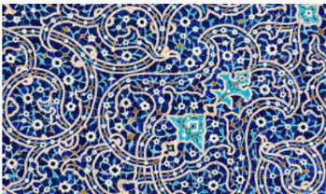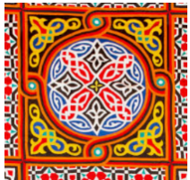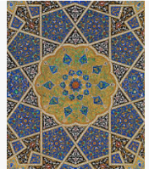  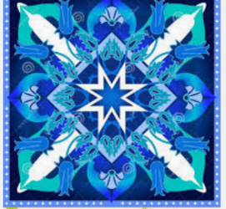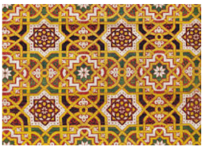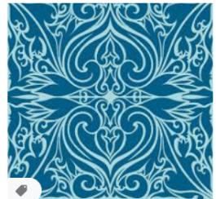 | William Morris  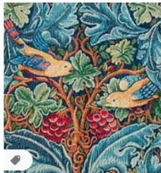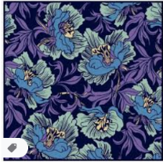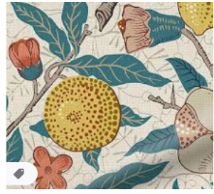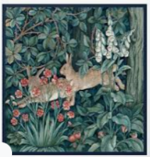  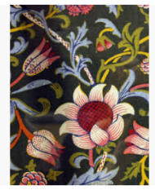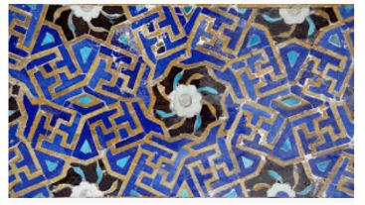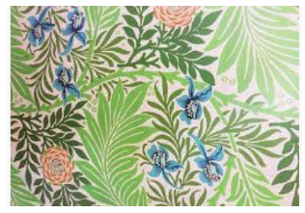
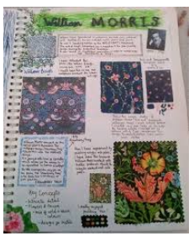
Explore and develop ideas
Lesson 1- First impressions
- Explain the theme of the above pictures is Printing. What does that mean to them? Do they know any printers?(FS1 found objects, Paul Klee and Y3 Collographs, Gordy Wright and Sarah Alps).
- Reduce the pictures above on paper for the children to cut out and stick in their sketchbooks. Ask them to annotate them, with single words, thoughts likes dislikes, similarities or differences between them. Discuss them together as a class.
- Introduce the artists:
This video is great for the history of Islamic art but how it is designed too. https://www.youtube.com/watch?v=pg1NpMmPv48
William Morris –Made by school children Y6 Stoneydown Park Primary https://www.youtube.com/watch?v=pl3EN407rbs
- Discuss their thoughts about the two forms of art, decorate their first impressions page in the sketchbook with thumbnail sketches of parts of a piece they like, the colours, used or the shapes they find.
- For homework can they use an A4 or A3 paper to investigate Morris or Islamic art, include examples, info, bio, pattern drawing, colours, shapes, plants, animals for Morris etc. Make the presentation as creative as possible. See examples below.

Investigating and making
Lesson 2 -Printing techniques – use monochrome for these investigations.
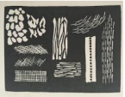
- 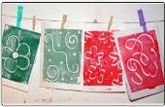 2. 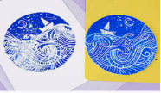 3. 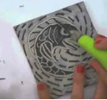 4.
- Monoprinting - https://www.youtube.com/watch?v=xOMWjWLAypQ use acrylic sheet
- Relief print - https://www.youtube.com/watch?v=a3KCNVJM-Ps use styrofoam sheet
- 3/4 Lino cut - https://www.youtube.com/watch?v=dchSXc12j6o use soft cut/easy cut lino sheets.
Try out some of the techniques on small pieces of Styrofoam and softcut lino sheets. Stick them in the sketchbooks and annotate which you liked best and why.
Lesson 3– Investigate design
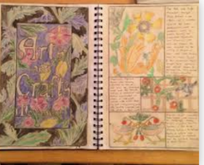
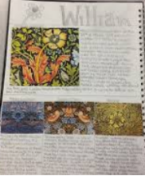
- Ask the children to choose the artist/movement that inspires them and research the designs.
https://www.youtube.com/watch?v=27iVbB656a0 draw an Islamic style pattern is a good one for drawing a simple design. Investigate online, choose and copy the whole or parts of designs you like best, colours and shapes you like. Keep them simple!
- Look at books about William Morris, his designs online, ask the children which they prefer the plants or animal themes? Draw thumbnail sketches, use tracing paper to trace the same design but in a different colourway , put together shades of a colour you find in a design in watercolour or pencil crayon, present your work in your sketchbook in a creative and interesting way. Again keep the designs relatively simple, especially if you want to lino cut.(see examples left)

Evaluating and developing work

Lesson 4 – Planning final piece
- Start to pull together ideas. Ask the children:
-Which artist/movement inspires them most?
-Will the design be more pattern or figurative based?
-Colours you want to use. Remember as you are printing, so you can do multiple copies, each in a different colour, monochrome or a mixture of two or three colours and mount the work together.
-Which printing technique will they choose?
- Draw the tile they would like to make as a line drawing to size in their sketchbook and annotate around it to describe their intentions and the colours of ink/paint they may use, and how many and in what arrangement they want to organise the prints they do into the finished piece.
- You could show them some finished work, see below.
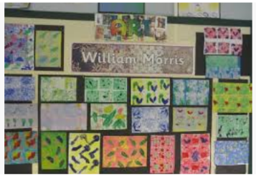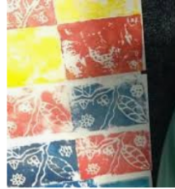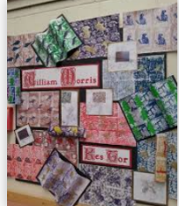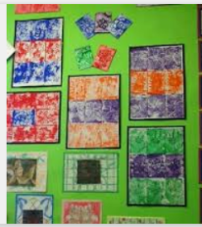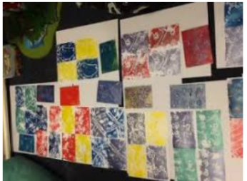

Lesson 5 – Final piece.
Create their final piece using all the skills and knowledge they have built up over the project.

Lesson 6 - Evaluation
- Prepare an evaluation sheet for the children to use to reflect on their learning.
Discuss together, do they like their work? Does it have the essence of the artists studied? How? Which bit is most successful? Why? If they did another piece would they change anything they’d done before? Why? Share these outcomes with the class and stick the sheet in the sketchbook to use for future reference
Lay the final pieces of work out around the class. The children walk round and then come back together as a class to say which they liked and why?

Y6 Sculpture
About this unit – This unit builds on architecture in 3D box modelling in Y1, to figurative sculpture using clay, wire, papier mache, salt dough in Y4. The children will now be working in a soft medium to produce still life objects inspired by pop and contemporary art movements.
Vocabulary | Suggested artists
Still life  Pop art  Contemporary art  Soft sculpture  Resources  Warhol Twinkl  Copies of the work by artists for children to review  Materials for constructing soft sculptures.  Fabrics  Plastic, paper  Prior learning  This unit builds on architecture in 3D box modelling in Y1, to figurative sculpture using clay, wire, papier mache and salt dough in Y4. | Andy Warhol 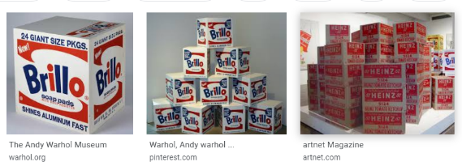 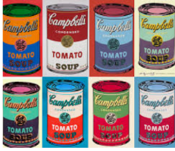  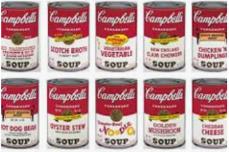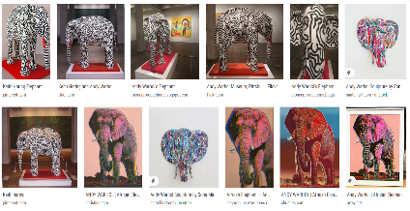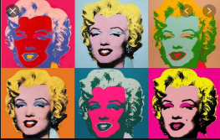 | Claes Oldenburgh  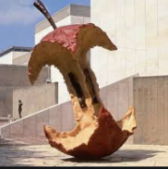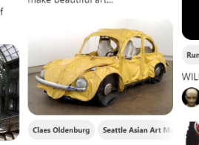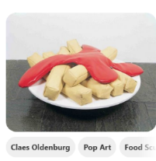  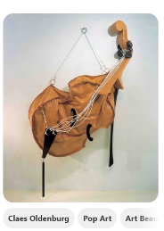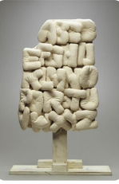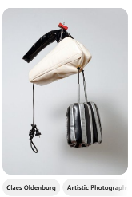
Explore and develop ideas
Lesson 1 – First impressions
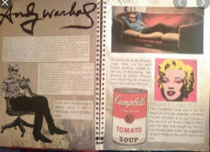
Stick the smaller photocopies of the pictures right in the middle of a sketchbook page. Ask the Children what they notice and label each around the pictures. Think about the subject, media, colour, time, art movement, artists, similarities, differences, personal response, what stands out? etc
- Ask them to write single words, sentences, thought bubbles, label different pictures. Do they see any similarities of differences between them? Describe them.
- Come together and look at some of the sketchbooks under the visualiser. Ask the children to talk about their work.
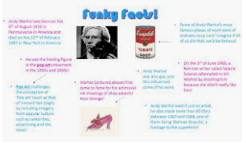
- Introduce the artists – Are the children familiar with any? Which movements do they belong to?
Warhol – Intro to pop art https://www.youtube.com/watch?v=DhEyoDCTSDQ Tate Kids
This video really gets under the skin of who Andy Warhol was. https://www.youtube.com/watch?v=QAJJ35DVlTs
Oldenburg - Soft sculpture https://www.youtube.com/watch?v=eB91flTprsI
- For homework can they find out about either or both the artists, Can they cover an A4 or A3 page with pictures from online, info, sketches of their own
- of the artists work. Think about the composition of the page, make it interesting and creative. See sketchbooks left.

Investigating and making
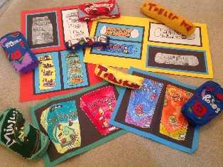
Lesson 2 – What is Soft sculpture? (Before this lesson ask the children to bring in an everyday item which interest them, eg a tube of toothpaste, a trainer, a tennis bat, a half peeled banana , a box of weetabix (to make another as tall as they are!)

Warhol and Oldenburg liked to take everyday objects and look at them from a different angle. Oldenburg took hard objects and made them soft, Warhol used bright fluorescent, clashing colours to change everyday objects. A few years ago Y2 were doing a topic on chocolate and made some soft sculptures of chocolate bars and boxes and tins. See left. (I still have these if you want to use them as a starting point).
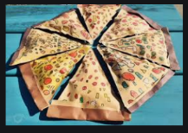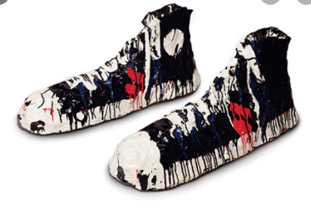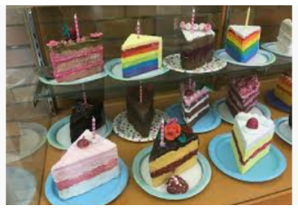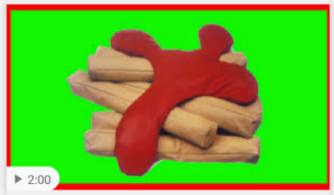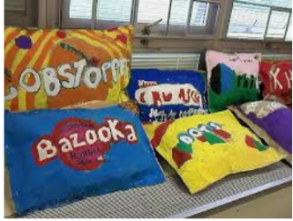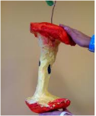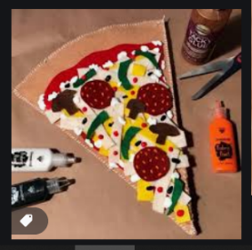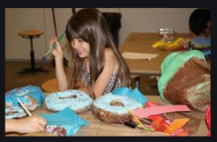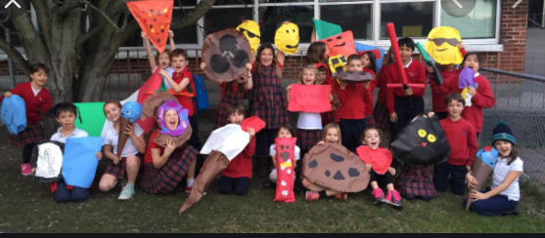
- These were made with felt but you could use any flexible material. Oldenburg used materials such as cardboard, burlap, and newspapers; in 1961 he shifted his method, creating sculptures from chicken wire covered with plaster-soaked fabric.
- Ask the children to look at their object(s). What would they like to change about their object when they make it into a soft sculpture?
- Ask them to draw the object a thumbnail sketch in their sketchbook as a line drawing, then photocopy it a couple of times and change the colour scheme to different colours, glittery, psychadelic, complementary colours, see the year 2’s drawings of chocolate boxes above.
- Annotate the designs with ideas for the materials they could use to make it with, eg fabric, cardboard, papier mache, plastic etc , and maybe stick some samples in their sketchbook.

Lesson 3 – Joining materials and inflating the sculptures
- Look back at their ideas for materials to use. They now need to think about how they are going to join them, you can show them the stitching on the chocolate boxes, but they could use glue, staples etc.
- What would they like to use to use to stuff their sculpture, paper, kapok (chocolate boxes) etc.
- Test out how strong the joins would be by having a go with different joining techniques and stuffing with different materials on a small scale and stick the annotated results in their sketchbooks.

Lesson 4 – Planning the final piece
- Discuss together what the children are hoping to make.
-How big will it be?
-What colour will it be?
-Which material will they make it from, and will it need to be painted eg lifesize box of weetabix!
-How will they join the materials?
-How will they stuff them if needed?
-Will they need any other embellishments? Sequins, shiny paper etc
- In their sketchbooks draw and colour a picture what they hope their final piece will look like.

Lesson 5/6 – Final piece and evaluation
- Gather together all the materials to make the final piece. When it’s made can the children take a photo to put in their sketchbooks?
- Prepare an evaluation sheet for the children to use to reflect on their learning.
- Discuss together, do they like their work? Does it have the essence of the artists studied? How? Which bit is most successful? Why? If they did another piece would they change anything they’d done before? Why? What have they learned? Share these outcomes with the class and stick the sheet in the sketchbook to use for future reference.
- Put out all the models for the children to look round to celebrate everyone’s efforts. Which pieces are their favourite? Why?

